Snubber Design

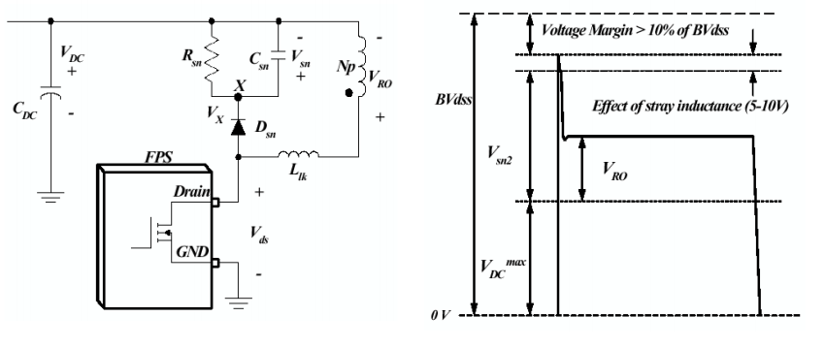

Figure 1: Snubber Design

In the snubber design, the purpose is to keep drain-source voltage of the MOSFET below its rated value. Also, the energy stored in the leakage inductance is dissipated on the snubber in order to avoid transformer from heating up. The rated Vds of the MOSFET is 200V. Vds=Vsn+VDC. Vdc =12 V. Keeping Vsn at 160 V is enough for safe operation of MOSFET and transformer. Rsn is calculated by the formula[reference:<https://e2echina.ti.com/cfs-file/__key/telligent-evolution-components-attachments/00-24-01-00-00-40-60-31/snubber-design.pdf> ]:

1 kΩ is used as snubber resistor.

As snubber capacitor(Csn), 10 µF is used in order to decrease the ripple on the Vsn

Power dissipation on the snubber is

$$P_{sn}=\frac{{V_{sn}}^{2}}{R_{sn}}=25.6W$$

This high amount of dissipation is due to large leakage inductance. In order to achieve desired magnetizing inductance, turns number on gapped transformers should be increased more compared to ungapped ones. Increasing turns results in higher leakage inductance.